Business Name
Address
City, State Zip

Dear Filer,

You are receiving this letter because you own rental properties in the City of Auburn. Owners of rental properties are required to report their associated business assets (personal property).

Historically, owners of rental properties seem unaware that they are eligible to receive a 100% property tax exemption on assets owned. This year we have updated our forms to help you receive this exemption.

If you provide a complete list of your owned assets and a signed BETE application pursuant to instructions, you will not have to pay taxes on eligible assets.

Enclosed you will find the Apartment Asset List. Please fill it out according to the instructions on the reverse of this letter. Your completed asset list must be returned either electronically or by mail to the Assessor's Office by April 16, 2024.

This is a request for information in accordance with MRS Title 36, Section 706-A. Property owners who fail to respond to the 706-A request will be subject to an estimated assessment and may waive their right to appeal the assessment.

Filing your asset list is the best way to ensure an accurate assessment. The Assessor's Office is available to help; we encourage you to stop by, call or email us with questions.

Sincerely,

Karen Scammon, CMA-4
Assessor

- Description of Appliance: List appliances that you own that are located at your rental properties. If you purchased appliances in bulk the same year you can list them together, otherwise list each appliance separately. See sample list below.
- Quantity: The number of appliances purchased together. Only group assets together if they are the same type and age.
- Year purchased: The year you purchased the equipment. If you purchased the appliances with the real estate, use the year you bought the building. In some cases, the age of the appliance will be older.
- New or Used: Report if you bought the appliance new or used.
- Age: List the age of the appliance. The asset may be older than the date purchased if you purchased it with the real estate. If you do not know the age of the appliance you may estimate. This is an important field; we use the age to estimate how much to depreciate your assets.
- Cost: The cost of the appliance. If you do not know the cost of an older appliance you may estimate.
- Sub-total: The total of the appliance costs (Quantity x Cost each = Sub-total) for each asset line.
- Location of equipment: The rental building where the property is located. Make sure you report the assets at every building owned.
- Other assets: If your business has other tangible assets, please also list these. For example: snowblowers, beds, vending equipment, computers, etc.
- Tenant owned: Do not list tenant owned appliances or equipment.
- BETE: We will accept this list as an attachment to the Business Equipment Tax Exemption Application if a signed BETE application is received with it
- Additional Pages: Use additional pages if needed. An excel version of this form can be found on our website: Assessing (auburnmaine.gov) If you would like us to email the excel document to you, please contact us.
Sample: 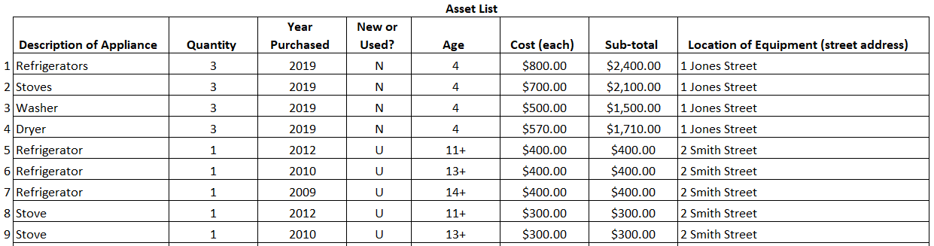
To file: Electronic filings are preferred, send your completed forms by email to assessing@auburnmaine.gov. To mail filings, send to: Assessor, 60 Court Street, Auburn, ME 04210. For assistance, please call 207-333-6601, choose option #4 when prompted.

